Planting Plan MIE Bee Border
Sandra Austin, April 2023

 | Plant Name | Common Name | Flower Colour | Flowering Time | Height (cm) | Spread (cm) | Position
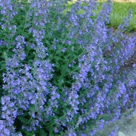 | NEPETA faassenii 'Walkers Low' | Catmint | violet/lilac | Jun/Oct | 50 | 50 | Mid
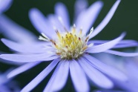 | ASTER 'Little Carlow' | Aster | purple/blue | Aug/Oct | 100 | 50 | Back
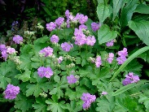 | GERANIUM cantab. Cambridge | Geranium | mauve | Jun/Oct | 20 | 50 | Front
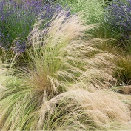 | STIPA tenuissima 'Pony Tails' | Mexican Feathergrass
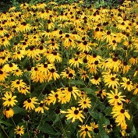 | RUDBECKIA fulgida 'Goldsturm' | Black-eyed Susan | yellow | Jul/Oct | 70 | 50 | back
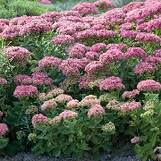 | SEDUM 'Herbstfreude' | Stonecrop | salmon pink/copper red | Aug/Oct | 50 | 50 | Mid
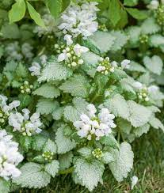 | LAMIUM maculatum 'White Nancy' | White Deadnettle | White | Apr/Aug | 20 | 50 | Front
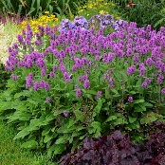 | STACHYS officinalis 'Hummelo' | Betony | purple/pink | Jul/Oct | 60 | 50 | Back
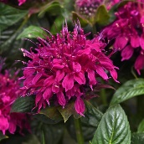 | MONARDA didyma 'Balmy Purple' | Bee Balm | red/purple | Jul/Oct | 30 | 50 | Front
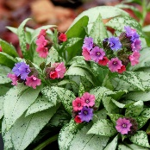 | PULMONARIA 'Silver Bouquet' | Lungwort | coral pink/violet | Apr/May | 30 | 50 | Front
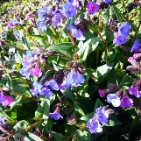 | PULMONARIA 'Blue Ensign' | Lungwort | violet blue | Apr | 30 | 50 | Front
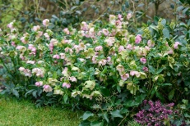 | HELLEBORUS 'Glam Bijoux' | Hellebore | maroon/purple | Dec/Mar | 45 | 45 | Front
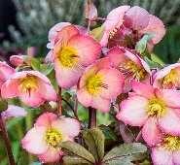 | HELLEBORUS 'Frostkiss Cheryl's Shine' | Hellebore | ivory/pink | Feb/Apr | 50 | 50 | Mid
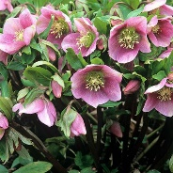 | HELLEBORUS orientalis | Hellebore | Cream-pink/Green | Jan-Apr | 50 | 50 | Mid
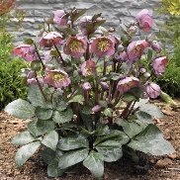 | HELLEBORUS 'Penny's Pink' | Hellebore | Pink | Jan-Apr | 50 | 50 | Mid
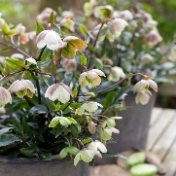 | HELLEBORUS 'Winterbells' | Hellebore | Cream-pink/Green | Nov/May | 50 | 50 | Mid
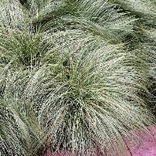 | CAREX comans 'Amazon Mist' | New Zealand Hair Sedge | Orange/Tan | Aug | 30 | 50 | Mid
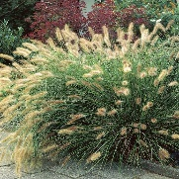 | PENNISETUM alopecuroides 'Hameln' | Fountain Grass | Cream/Purple | Jul-Sep | 100 | 100 | Back

